**Factor ETFs outperformed sector ETFs:**

**A Statistical Test**

Relatore: Prof. Mariateresa Ciommi Tesi di Laurea di: Huynh Son Tha

Anno Accademico 2021 - 2022

Table of Contents

1. Introduction 1

2. Literature review 4

2.1 Pillars of modern asset pricing 4

2.1.1 Efficient market hypothesis 4

2.1.2 Capital Asset Pricing Model (CAPM) 6

2.1.3 Multifactor models 9

2.2 Pillars of this study 14

2.2.1 Efficient frontier 14

2.2.2. Exchange traded funds (ETFs) 16

3. Methodology 19

4. Data 21

5. Empirical analyses 26

5.1 Descriptive statistics 26

5.2 Building the efficient frontiers 31

5.3 Beating the market 33

5.4 Efficient frontier comparison: factor outperformed sector 35

6. Conclusion 42

References: 44

Appendix A: Descriptive figures 48

A1: Sector ETFs 48

A2: Factor ETFs 50

Appendix B: Python codes 52

List of Figures

Figure 1: Efficient frontier 14

Figure 2: Correlation coefficients for sector ETFs 28

Figure 3: Correlation coefficients for factor ETFs 29

Figure 4: Efficient frontiers for factor and sector ETFs 30

Figure 5: Beating the market portfolio 31

Figure 6: Factor outperformed sector 34

Figure 7: Components of Momentum and Value ETFs 38

List of Tables

Table 1: Descriptive statistics for sector ETFs, full sample 25

Table 2: Descriptive statistics for factor ETFs, full sample 26

Table 3: The measures of efficiency between market portfolio and efficient frontiers 32

Table 4: The measures of efficiency between factor and sector efficient frontiers 35

# Abstract

By applying the geometric test for mean-variance efficiency proposed by Basak, Jagannathan, and Sun (2002) (henceforth BJS), this study examines overall performances of two prominent investing approaches: multifactor and sector diversification. Results from the full sample (August 2013 – December 2020) indicate that the former outperformed persistently the latter with statistical significances, while the conclusion was blurrier during the pandemic period (2020). Unlike other research, which try to deliberately construct original factors from individual stocks (Briere and Szafarz (2021), for instance), this thesis leverages the availability of exchange traded funds (ETFs), whose purposes are to reproduce the risk premiums of those pre-defined investing baskets, hence it provides more practical implementations of the research outcomes.

Astratto

Applicando il test geometrico per l'efficienza media-varianza proposto da Basak, Jagannathan e Sun (2002) (d'ora in poi BJS), questo studio esamina le prestazioni complessive di due importanti approcci di investimento: la diversificazione multifattoriale e settoriale. I risultati del campione completo (agosto 2013 – dicembre 2020) indicano che il primo ha constantemente sovraperformato il secondo con significatività statistica, mentre la conclusione è stata meno chiara durante il periodo della pandemia (2020). A differenza di altre ricerche, che cercano di costruire volutamente fattori originali dai singoli titoli (Briere e Szafarz (2021), per esempio), questa tesi sfrutta la disponibilità di fondi negoziati in borsa (ETF), i cui scopi sono riprodurre i premi di rischio di quelli pre -definiti portofolio di investimenti, quindi fornisce implementazioni più pratiche dei risultati della ricerca.

# 1. Introduction

In modern portfolio management, the act of grouping various assets into a portfolio generally serves for either diversification benefits or risk premiums. The former has been notably established in the field, especially through sector indices to reduce the overall volatility of the portfolio (De Moor & Sercu, 2011), the latter, however, has maintained one of the most dynamic research subjects over the years, starting from the birth of CAPM to Fama-French 5 factor models (FF5) and the “factor zoo”[1] as of nowadays. These specific models will be discussed more in depth in the next section.

Theoretically, stock returns are primarily stemmed from risk premiums that they are exposed to. This logic was a bedrock for active investors whose jobs was to exploit any inefficiencies in the financial market. An active approach provides portfolio managers flexible maneuverability in selecting specific stocks in an effort to outperform a pre-defined benchmark. Adversely, a passive approach generally tracks the performance of an index by constructing a portfolio that has the same underlying stocks of the index. For instance, a S&P500 index is a portfolio comprised of 500 largest stocks in the US market, so investors, instead of purchasing 500 individual stocks, now can buy that index to get the identical performance. While the former tries to gain extra excess returns based upon asset miss-pricing, the latter believes wholly in the efficiency of the market performance in general.

Generally, high charged fees, including principally management fees and transaction costs, are the mostly criticized characteristic of active investing, while this aspect is relatively low for passive approach. Specifically, in an effort to replicate the risk premiums from original factors, fund managers typically have to scan through the entire market, and then classify certain stocks into proper portfolios based upon their performances. Not surprisingly, this whole process is time consuming and difficult, not only tediously requires labor works but also remarkably desires professional knowledge for sensible alterations. However, the critical aspect of the high fee is due to transaction costs, which arise when those managers have to frequently rebalance their portfolio weights to reflect updated fluctuations of all the traded stocks. These features mostly explain high fees charged by those active funds. The birth of ETF, however, has somewhat solved these issues since the prices of traded ETF already reflected the rebalancing costs of underlying baskets. Furthermore, investors can trade these ETFs simultaneously as normal stocks, hence the possibility of grouping them into a diversified portfolio may be promising, not only regarding to the potential of risk premiums, but also the diversification benefits that these ETFs may offer.

The natural questions, therefore, are arose: can these multifactor portfolios, comprising of traded ETFs, beat those traditional sector diversifications? In addition, is that conclusion statistically significant? The study leveraged statistical properties of Basak, Jagannathan, and Sun (2002), and followed the testing procedures suggested by Ehling and Ramos (2006) to compare direct performances of factor and sector ETFs for the period from August 2013 to December 2020, including the global pandemic year (2020) to consider its impact. Results from this empirical study suggest that factor ETFs (i.e., an efficient frontier combined of various factor ETFs) indeed outperformed sector ETFs (i.e., an efficient frontier mixed of diverse sector ETFs) with statistical significances for the full sample, while the same conclusion was detected during the pandemic period but without statistical significance.

The obvious advantage of adopting ETFs, instead of replicating original factors based upon all traded stocks, is that results from the study will be easily applied by either institutional or retail investors, since grouping ETFs is as simple as grouping individual stocks. Furthermore, in adapting to this highly volatile and fluctuated market, an ease of rebalancing portfolio’s weights would be another great asset over the traditional approach in constructing factors from scratch, not to mention the lower transaction costs and less time requirements.

The remanding thesis is organized as follows. The building blocks and its evolution of modern asset pricing are presented in the next section. Then, details of the BJS (2002) test and procedures of how to implement it in case of comparing two efficient frontiers (factor ETFs and sector ETFs) will be discussed. Section 4 will describe the data for these ETFs, as well as the market portfolio (S&P 500). Section 5 will present the empirical analyses, ranging from descriptive statistics to comparing each investing approach with the market portfolio and between the two approaches. Section 6 will conclude the thesis with remarks on potential research improvements.

# 2. Literature review

## 2.1 Pillars of modern asset pricing

### 2.1.1 Efficient market hypothesis

The first brick of the modern asset pricing foundations was laid-out by a French financial mathematician: Louis J.B.A Bachelier (1870-1946). Previously studied in mathematical physics, he turned his interest into analyzing the prices of warrants traded in the Paris stock market when he prepared for his PhD thesis under the famous mathematician Henry Poincare. He discovered, written in his thesis “Theory of speculation” in 1914, that the prices distributed randomly, and investors could never gain profits from the past price patterns, and he concluded, “the mathematical expectation of the speculator was zero”. However, his revolutionary finding was not recognized until almost half a century later by the works of two authors, who will be Nobel Prize winners, a physicist-turned-economics Paul A. Samuelson and an Italian-American financial economist Eugene F. Fama. While Samuelson (1965) originally introduced the Martingale process[2], Fama (1965) followed an established Random walk model[3] to arrive almost the same conclusion: the currently traded price of an asset is already accounted all available information related to that asset. This is the heart of the Efficient Market Hypothesis (EMH) that we know today. Fama, though, coined the term “*efficient market”* in his writing:

*“An “efficient” market is defined as a market where there are large numbers of rational, profit-maximizers actively competing, with each trying to predict future market values of individual securities, and where important current information is almost freely available to all participants. In an efficient market, on the average, competition will cause the full effects of new information on intrinsic values to be reflected “instantaneously” in actual prices”. [1965b, 56]*

Lo (2017) acknowledged two layers of EMH sophistications from Fama’s works: “The Efficient Markets Hypothesis is a hypothesis about what information is available to market participants, and a second hypothesis about how prices fully reflect that information. The early tests of efficient markets focused on the “what”, evaluating which various types of information were or were not reflected in market prices. But the question of the how, the way markets actually incorporate information into prices is equally important— and much less obvious from the mathematics”. Unlike the laws of nature which are deterministically pre-defined such as quantum mechanics, general relativity, and so on, the EMH holds because of interactions among market participants. Each one of them will try to profit from even the least possible edge in historical information, and an army of players whose movements are to exploit instantly that inefficiency, will remove the profit opportunity and bring back the equilibrium. EMH was widely, empirically proven throughout the following years such that Jensen (1978) regarded “there is no other proposition in economics which has more solid empirical evidence supporting it than the Efficient Market Hypothesis.”

### 2.1.2 Capital Asset Pricing Model (CAPM)

The other important pillar of the asset pricing foundation originated from the trade-off between risk and reward. The latter was handily derived as the expected return of the asset/portfolio over the review period. The former, however, was subtler in measuring. It could be the total volatility of the asset’s returns (reflected through standard deviation) or downside risk (measured as the loss likelihood or the maximum drawdown). For instance, an overall standard deviation of a portfolio could be 15%, however, the downside risk could be 19% which may be measured based upon maximum drawdown ratio. The relationship between risk and reward was drastically changed after William F. Sharpe published his work in 1964 (almost the same period of the EMH discovery). In his paper, he noticed that stock return fluctuations could be divided into two components. The first element, he called “idiosyncratic”, changes that were generated by unique aspects of the asset, such as a change in business direction, a present of a new innovative product in the industry, or a personal scandal of the CEO, to name a few, and the second component, he referred as “systematic”, changes that were brought up by the general, market-wide circumstances such as unemployment rate, inflation, or oil shock. He further suggested that investors should be rewarded only for their systematic risk, not idiosyncratic one. In his reasoning, supported by mathematical formulations, since idiosyncratic risk was specifically isolated by individual assets, they could generally be eliminated by blending a substantial number of assets into a portfolio (the less correlated, the better). Nonetheless, no matter how many assets an investor incorporated, the systematic risk, which was shared by all assets, would not be canceled out. This aspect was previously raised by will-be-another-Nobel-prize-winner Harry Markowitz in 1952: “This presumption, that the law of large numbers applies to a portfolio of securities, cannot be accepted. The returns from securities are too inter-correlated. Diversification cannot eliminate all variance.”

Therefore, a reward should be compensated for those who accepted this risk – it is nowadays known as a *risk premium*. This analysis, combined with an independent work of Lintner (1965), helped formulate the first formal model for asset pricing, hence the name Capital Asset Pricing Model (CAPM). The model essentially illustrated the relationship between systematic risk and expected return of an asset:

Where: : risk-free rate, normally measured by the rate of 30 days to maturity Treasury Bill, is the expected return of the market portfolio, commonly represented by S&P500 index which is a basket of 500 largest capitalization values in the US market. And , calculated as is the measure of systematic risk of the asset, the only relevant risk that investor should be rewarded for. Clearly shown from the model, an asset’ expected return is linearly proportional to its . If an asset, for instance, has beta of 3, then it would have three times the systematic risk of the market portfolio, hence the expected return of that asset should be triple the risk premium of the market portfolio.

CAPM was a revolutionary idea that transformed the entire field of investing (indeed, in 1990, Sharpe was awarded a Nobel prize for this work, among other contributions). Not only it shed the new light into asset’s expected returns, but also helped provide a measure for portfolio performance. Specifically, Sharpe (1966), and Jensen (1968) leveraged the linear relationship to judge performance of a mutual fund manager by comparing directly excess return of the portfolio with the CAPM benchmark, called “alpha” (:

The manager added values to the portfolio if a positive alpha was found, meaning that the portfolio earned higher expected return then the level suggested by the CAPM, and this excess return explained the fees charged by the manger.

A clear conclusion from the EMH was that no one could consistently predict the future movements of an asset’s prices, combining with the fact that only the systematic risk (as measured by ) would be rewarded, an entirely new investment vehicle was born: index funds. Based primarily upon direct results of both EMH and CAPM, an index fund would attempt to replicate the performance of an underlying market index. An investor, for instance, could trade an entire S&P500 by purchasing a S&P500 index fund with a small fee instead of individually collecting 500 different stocks into a portfolio. In other words, index funds promised to convey only beta, no alpha at all. Because index funds did not try to delivery alpha (i.e., “beat the market), they’d require less resources such as talented professionals, computing power, and so on, hence significantly lower the fees they’d charge clients. Therefore, it helped provide an accessible investment channel for the public to approximately gain expected returns as high as the market’s. And after its inception in the 1970s, index funds have blossomed into trillions of dollar industry thanks to its conveniences.

### 2.1.3 Multifactor models

As the field evolved over time, some empirical results appeared to against the CAPM model. Specifically, Banz (1981) examined the monthly relationships between the market and common stock returns from 1926 to 1975, and pointed out that small firms (represented by low market capitalization) had higher returns than that of large firms, after controlling for the market risk. This size effect, as he called, was observed only for a set of very small stocks, and vanished when compared between medium and large stocks. To further investigate this anomaly – as CAPM claimed, Basu (1983) designed his test for traded stocks from 1962 – 1978 with a dual goal: how a firm’s earnings ratios E/P[4] and size affected its returns? The finding, as he stated “common stock of high E/P firms earn, on average, higher risk-adjusted returns than the common stock of low E/P firms and that this effect is clearly significant even if experimental control is exercised over differences in firm size”, once again showed the incapability of CAMP in explaining various stock returns over the years. Rosenber et al. (1985) established two instrumental variables, book/price strategy (buy high book/price stocks, simultaneously sell low book/price stocks) and specific-return-reversal strategy (calculated disparity between actual and CAPM-fitted stock returns of the previous month), to argue that investors could, in principle, beat the market if they can “identify the valuation errors that correlate with these instruments”.

As a result of a series of empirical evidence opposed to the CAPM, Fama and French (1993) formally proposed a three-factor model (FF3) in an effort to capture stock’s expected returns related to both size and book-to-market ratios. They introduced the two new explanatory variables to the CAPM model, including SMB, measured as the return differences between small stocks less big stocks, and HML, as high B/M[5] ratios minus low B/M ratios (they defined stocks with high B/M as value stocks since the market prices were closely reflected by the book values, not like stocks with low B/M, which were regarded as “growth” stock because these stock’s intrinsic values were immensely depended into their future prospects):

Clearly seen from the model, if the coefficients, , and , fully reflected changes in expected returns, then the intercept would be approximately zero. FF3 extended dependency of a stock/portfolio expected return on the size effect and value effect, not just the market fluctuations as the CAPM suggested. It, both theoretically and practically, made sense from the standpoint of risk considerations. Small firms and low book-to-market values should be logically risker than big firms and high book-to-market values, respectively. And because of that, investors should be rewarded for accepting these extra risks. This extension hugely succeeded in explaining the fittest of observed returns, hence opened an entirely new field: active investment. Contrast to the index funds which were passively invested into the market portfolio, investors realized that if they could construct their portfolios based additionally on two other factor exposures from the FF3, the excess returns, after controlling for the market risk, would be realistically possible to earn.

Carhart (1997), motivated by the FF3’s inability of explain cross-sectional variation in momentum-sorted portfolio returns (Fama and French 1996), added on the fourth factor to extend the FF3 model: momentum. He defined this momentum variable as “equal-weight average of firms with the highest 30 percent eleven-month returns lagged one month minus the equal-weight average of firms with the lowest 30 percent eleven-month returns lagged one month”. By applying the extended version of the FF3 model on the monthly returns of mutual funds for the period January 1962 - December 1993, he revealed that “funds with higher returns last year have higher-than-average expected returns next year”. Apparently concluded from this study, investors would demand a risk premium for holding stocks that performed poorly in the previous year, regarding of their size, book-to-market value, and their systematic risks.

Investigating the relationship between abnormal stock returns and firm’s investments, Titman et al. (2004) empirically revealed the negative impact of capital expenditures and stock prices, stressing the price fluctuations around earning-announced events. The study applied a set of three tests on a large number of samples (1,635 firms a year for a period from July 1973 to June 1996). The article unveiled that those indicated factors (factors included size, book to market, momentums, and systematic risk) failed to explain the higher returns of low-level invested firms. In order words, the excess returns for holding stocks that spent less of their funds pursuing new investment opportunities was not associated with the mentioned factors. Obviously, investors unfavorably evaluated the news about firm’s enlargement, considered it as a sensitive stock to hold, and hence asked for a risk premium. In addition, Novy-Marx (2012) regressed monthly returns of stocks traded in the US market from July 1963 to December 2010, and revealed that profitable firms – measured by high ratios of gross profit-to-asset, earned higher returns compared to unprofitable firms. Investing in the latter case was deemed riskier (since they were considered as more likely to be insolvent, or less capable of maneuverability under difficult situations), and empirically showed that the investors were indeed compensated by this extra exposure. With primarily apparent evidence from these two studies, Fama and French (2015) re-constructed their FF3 model by augmenting the profitability and investment factors as below:

Where RMW was calculated as the disparity between “robust minus weak” profitability, and CMA was the difference between low versus high investments in which they called conservative and aggressive, respectively. To empirically tested how well the five factor-model (FF5) performed, they sorted portfolios (according to the factors) comprised of all traded stocks in NYSE, Amex, and NASDAQ for the period from July 1963 to December 2013, and concluded that “the model explains between 71% and 94% of the cross-section variance of expected returns”. Surprisingly, FF5 – with their empirical success, did not incorporate the well-established momentum factor.

These multi-factor models, since then, have been widely expanded into a so-called “factor zoo” (a term introduced by Cochrane, 2011) with over a hundred of considered factors. For instance, Ibbotson et al (2013) studied the relative importance of liquidity[6] in stock’s long-term returns from 1972 to 2011. They constructed yearly-basis portfolios based upon four distinct factors (size, value, momentum and liquidity) over the review period, and pointed out that liquidity apparently differentiated portfolio returns likewise the other three widely accepted factors. Further strengthened the argument, the article treated liquidity as a series of returns in an attempt to linearly regress it with other style factors. It was shown that the monthly alphas (the intercept left over from the multivariate regressions) were all positive and significant, thus suggesting that liquidity may be used as a factor in modeling stock prices. Or another paper written by Chou et al (2019) suggested that there was a robust connection between asset growth (AG) and ex-ante stock returns. Specifically, they proposed and tested a hypothesis that AG acting as a guiding factor could help achieve superior and more consistent profitability than conventional factors such as value and size. These alike papers have contributed to a heating debate whether there exists a small, distinct set of factors that are statistically, practically suitable in asset pricing. And CAPM, FF3, FF5, combined with momentum seemed to be the shortlisted candidates for this matter.

## 2.2 Pillars of this study

### 2.2.1 Efficient frontier

Traditionally, investors selected each individual stock based completely upon their historical returns and fluctuations. Put it simply, if an investor fixed a certain level of return for an accepted risk, then a typical stock-collected process would be effortlessly proceeded by comparing whether a stock met that requirement. Mathematically speaking, this mechanism led to undesired results since it ignored the most foundational consideration: correlations among the chosen stocks. Markowitz (1952) presented a comprehensive framework, called mean variance optimization, precisely described how to construct a modern portfolio. Specifically, he showed that portfolio’s volatility was significantly reduced if we’d combine unrelated or better yet negatively correlated stocks, and it would not affect the expected return. There were several assumptions underlying the theory, but two were prominent:

* Investor’s preferences were fully captured by portfolio’s first two static moments: expected return and volatility
* Investors were rational, meaning that they would prefer a portfolio that had a lower level of risk given the same level of return, or vice versa, higher return for the same level of risk.

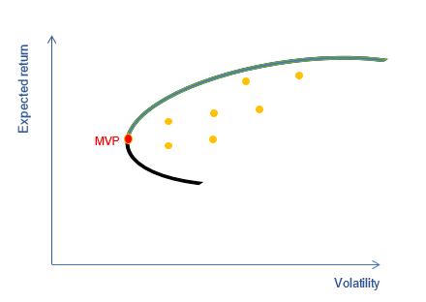

Figure : Efficient frontier

Markowitz showed that there was a specific area where investors could combine different stocks with various weights to construct their investable portfolios, and it was bounded by the curved line as shown in the figure 1. He graphically suggested that those orange dots were not efficient in a sense that investors could simply move vertically up (to earn higher returns with the same volatility), or move horizontally left (to reduce volatility with the same return). He called the red dot the MVP, “minimum-variance portfolio”, since there was no way one could get lower volatility than this portfolio. He further implied that investors would chose only the blue part of the curved line (started at the MVP), and named it the “efficient frontier”. Depending upon each investor’s preferences about risk favors, they would move along the efficient frontier since it would guarantee increased returns for an additional unit of volatility. No rational investor would deviate from this basic principle.

### 2.2.2. Exchange traded funds (ETFs)

An index fund, as depicted before, helped investors to mimic performance of the market portfolio by trading one ticker instead of a dozen of individual stocks. A natural question arose, especially when CAPM was proved to be insufficient to capture excess returns adjusted for the market risk: Could we replicate performance of mutual funds and made it available to the market as a freely traded investment vehicle? Exchange traded funds (ETFs) were born to answer precisely that question. Essentially, an ETF provider, such as BlackRock or Vanguard, would examine broadly different assets and build an investable basket out of these assets based upon certain criteria (for instance, tracking a specific sector, distinct size, value or momentum factors, and so on), just like a regular mutual fund but with much lower charged fees. They would offer this basket to the market with a specific ticker to trade, and investors can purchase a share of the basket, typically similar to buying shares of a company. Investors, then, could trade these ETF tickers openly on an exchange, considerably like a stock. However, diversification benefit was a hugely dominant advantage of an ETF compared to a regular stock as a result of the underlying ETF’s basket which comprised of multiple assets.

Broadly speaking, traditional ETFs were constructed based on capitalization-weighted design. Stocks with higher market capitalizations were weighted proportionally more than stocks with lower market capitalizations. Accordingly, these ETFs were mostly represented by a few of large stocks. To avoid this consolidation issue, “smart beta” indexes, referred to index funds or ETFs, were formulated with the objective of sharpening diversification or adjusting risk exposures. Smart beta, therefore, could be generally classified into two types as FTSE Russell[7] defined:

* Alternative to weighted indexes — typically designed to address perceived concentration risks in capitalization-weighted indexes or reduce volatility within the index;
* Factor indexes — designed to replicate factor risk premiums in a transparent, rules-based and investable format.

Put if differently, the first category was to increase the diversification benefits over capitalization-weighted index (mostly through combined different industries instead of selecting high valued stocks), and the latter was to capture excess returns recommended by a series of scholarly published papers about superior factors (such as size, value, momentum or volatility) in asset pricing literature.

# 3. Methodology

Universally considering a set of m primitive assets over the period of time N, the corresponding set of returns are modeled in the vector r = (r1, r2,…,rm), with the expected return: E(r) = μ and covariance: Cov(r) = E[(r – μ) (r – μ)T] =. In addition, a weighting vector w = (w1, w2,…,wm) represents the portion of asset i in the portfolio comprising of m primitive assets, and then the return of the portfolio is calculated as: rp = wTr =. The portfolio must follow the budget constraint: **1**Tw = 1, where **1** is the vector that contains only the value of ones as their elements.

The study employs the geometric test for mean-variance efficiency, which was proposed by Basak, Jagannathan, and Sun (2002). Specifically, given a benchmark portfolio with expected return β, and variance ѵ, the efficiency measurement is defined as the difference between the variance of the benchmark portfolio with its identically expected return counterpart depicting on the efficient frontier of p primitive assets. The efficiency measure: , accordingly, is the solution of the following optimization problem:

(P)

Under the null hypothesis: , the benchmark portfolio is mean-variance efficient, and BJS proved that asymptotically follows a normal distribution:

Where is the variance of the efficiency measure with sample size N.

In case the null is rejected, if is negative, the benchmark portfolio has higher variance than that of its counterpart in the frontier while both of the portfolios have the same level of return, meaning the benchmark portfolio is not efficient. In contrast, a positive value of indicates that the benchmark portfolio is efficient.

BJS paper originally designed this test to compare a market portfolio as the benchmark, which was calculated by value-weighted index of stocks traded on NYSE, Amex and NASDAQ, with 25 size and book-to-market portfolios as the primitive assets. Subsequently, Ehling and Ramos (2006) applied the BJS test to compare two different efficient frontiers with each other. They first anchored one of the efficient frontier, then picked two special points on the other frontier (the minimum variance portfolio and the tangency portfolio) and treated these two as benchmark portfolios. The tangency portfolio, which lines in the efficient frontier, is commonly called the reward-to-variability or Sharpe ratio (SR), representing the excess return of the portfolio relative to the risk-free rate, rf, over the portfolio’s standard deviation, and explicitly formulated as

Finally, they adopted the BJS test with the reference frontier and the benchmarks respectively. Ehling and Ramos (2006) suggested that the reference frontier is mean-variance efficient compared to the other if one of the benchmark portfolios is significantly inefficient based on the BJS test. This thesis will follow the same procedures to measure the mean-variance efficiency of sector and factor ETFs.

# 4. Data

The primary objective of the research is to provide practical comparison about investable portfolios, particularly a list of sector ETFs versus a set of factor ETFs. The result from this approach would be more convenient than Briere and Szafarz (2021) which constructed sector and factor indexes by all traded stocks in the US market. The latter case required investors to collect and adjust individual stocks manually to replicate the paper’s results while this time consuming, tedious work can be implemented directly through vastly available ETFs in the market.

All selected ETFs are designed by Blackrock – the world’s largest asset manager, with more than US 8 trillion assets under management (December 2020). The historical monthly returns are retrieved from Center for Research in Security Prices (CRSP)[8] for the period from August 2013 to December 2020, including:

1. 12 sector ETFs:

* Utilities: the sector will be presented by the iShares U.S. Utilities ETF (ticker IDU) with objective: “seeks to track the investment results of an index composed of U.S. equities in the utilities sector, including electricity, gas, and water”.
* Consumer: the sector will be presented by the iShares U.S. Consumer Discretionary ETF (ticker IYC) with objective: “seeks to track the investment results of an index composed of U.S. equities in the consumer discretionary sector, including food, drugs, general retail items, and media”.
* Financials: the sector will be presented by the iShares U.S. Financials ETF (ticker IYF) with objective: “seeks to track the investment results of an index composed of U.S. equities in the financial sector, including banks, insurers, and credit card companies”.
* Financial Services: the sector will be presented by the iShares U.S. Financial Services ETF (ticker IYG) with objective: “seeks to track the investment results of an index composed of U.S. equities in the financial services sector, including investment banks, commercial banks, asset managers, credit card companies, and securities exchanges”.
* Healthcare: the sector will be presented by the iShares U.S. Healthcare ETF (ticker IYH) with objective: “seeks to track the investment results of an index composed of U.S. equities in the healthcare sector, including healthcare equipment and services, pharmaceuticals, and biotechnology companies”.
* Industrials: the sector will be presented by the iShares U.S. Industrials ETF (ticker IYJ) with objective: “seeks to track the investment results of an index composed of U.S. equities in the industrials sector, including companies that produce goods used in construction and manufacturing”.
* Consumer Staples: the sector will be presented by the iShares U.S. Consumer Staples ETF (ticker IYK) with objective: “seeks to track the investment results of an index composed of U.S. equities in the consumer staples sector, including companies that produce a wide range consumer goods, automobiles, and household goods”.
* Materials: the sector will be presented by the iShares U.S. Basic Materials ETF (ticker IYM) with objective: “seeks to track the investment results of an index composed of U.S. equities in the basic materials sector, including companies involved with the production of raw materials, metals, chemicals and forestry products”.
* Real Estate: the sector will be presented by the iShares U.S. Real Estate ETF (ticker IYR) with objective: “seeks to track the investment results of an index composed of U.S. equities in the real estate sector, including real estate companies and REITs, which invest in real estate directly and trade like stocks”.
* Transportation: the sector will be presented by the iShares U.S. Transportation ETF (ticker IYT) with objective: “seeks to track the investment results of an index composed of U.S. equities in the transportation sector, including airline, railroad, and trucking companies”.
* Technology: the sector will be presented by the iShares U.S. Technology ETF (ticker IYW) with objective: “seeks to track the investment results of an index composed of U.S. equities in the technology sector, including electronics, computer software and hardware, and informational technology companies”.
* Telecommunication: the sector will be presented by the iShares U.S Telecommunications ETF (ticker IYZ) with objective: “seeks to track the investment results of an index composed of U.S. equities in the telecommunications sector, including companies that provide telephone and internet products, services, and technologies”.

1. 7 factor-based ETFs:

* US Size: this factor will be presented by the iShares MSCI USA Size Factor ETF (ticker SIZE) with objective: “seeks to track the investment results of an index composed of U.S. large- and mid-capitalization stocks with relatively smaller average market capitalization”.
* US Min Vol: this factor will be presented by the iShares MSCI USA Min Vol Factor ETF (ticker USMV) with objective: “seeks to track the investment results of an index composed of U.S. equities that, in the aggregate, have lower volatility characteristics relative to the broader U.S. equity market”.
* EM Min Vol: this factor will be presented by the iShares MSCI Emerging Markets Min Vol Factor ETF (ticker EEMV) with objective: “seeks to track the investment results of an index composed of emerging market equities that, in the aggregate, have lower volatility characteristics relative to the broader emerging equity markets
* EAFE Min Vol: this factor will be presented by the iShares MSCI EAFE Min Vol Factor ETF (ticker EFAV) with objective: “seeks to track the investment results of an index composed of developed market equities that, in the aggregate, have lower volatility characteristics relative to the broader developed equity markets, excluding the U.S. and Canada, including stocks in Europe, Australia, Asia and the Far East with potentially less risk”.
* iShares MSCI USA Momentum Factor ETF (ticker MTUM) with objective: “seeks to track the investment results of an index composed of U.S. large- and mid-capitalization stocks exhibiting relatively higher price momentum”
* iShares MSCI USA Quality Factor ETF (ticker QUAL) with objective: “seeks to track the investment results of an index composed of U.S. large- and mid-capitalization stocks with quality characteristics as identified through certain fundamental metrics, including high return on equity, stable year-over-year earnings growth and low financial leverage”.
* iShares MSCI USA Value Factor ETF (ticker VLUE) with objective: “seeks to track the investment results of an index composed of U.S. large- and mid-capitalization stocks with value characteristics and relatively lower valuations based on fundamentals”.

1. Treasury Bill (T-bill) with 30 days to maturity is treated as the risk free rate.
2. And lastly, returns on the Standard & Poor's Composite Index (S&P500) is considered as the market portfolio.

# 5. Empirical analyses

## 5.1 Descriptive statistics[9]

Table : Descriptive statistics for sector ETFs, full sample

Notes to table: This table reports descriptive statistics for 12 sector ETFs (Utilities, Consumer, Financials, Financial services, Healthcare, Industrials, Consumer staples, Materials, Real estate, Transportation, Technology, and Telecommunication). The sample covers the period from August 2013 to December 2020

- First developed by William Sharpe (1966), Sharpe ratio, which is considered as one of the most cited ratios in measuring financial performance, calculates the excess expected return over its volatility (standard deviation) of an investment. The higher the ratio, the better the investment. While the ratio for sector ETFs ranged from practically zero (Utilities) to 0.23 (Healthcare), the ratio for factor ETFs had higher spectrum, ranging from 0.07 (EM minimized volatility) to 0.33 (US momentum), indicating that on average, the factor ETFs earned more excess returns after adjusting for its risk.

- For skewness - a measure of symmetry in data distributions, all sector ETFs were negative, except Telecommunication (0.23), and they varied notably across industries. Factor ETFs had lower level of variability, from -0.8 (US Min Vol) to -0.28 (US Quality). The same pattern arose in terms of measuring statistical distributions by Kurtosis. A larger, wider Kurtosis range was found in sector ETFs, from 3.19 (Telecommunication) to 48.7 (Consumer), compared to the factor ETFs range (from 3.4 to 7.6), suggesting a higher level of risk associated with sector investments.

Table : Descriptive statistics for factor ETFs, full sample

Notes to table: This table reports descriptive statistics for 7 factor ETFs (EM Min Vol, EAFE Min Vol, US Momentum, US Quality, US Size, US Min Vol, and US Value). The sample covers the period from August 2013 to December 2020covers the period from August 2013 to December 2020

- As pointed out by Ang, Chen, and Xing (2006), investors pay more attention to downside risks, rather than the overall volatility. Specifically, the latter measures the variability of returns around the expected value, regardless of the sign. This is rarely the case in reality where "agents who place greater weight on the risk of downside losses than they are attach to upside gains demand greater compensation for holding stocks with high downside risk". In order to measure this downside risk, many methods have been proposed over the years, however Value at Risk (VaR) is considered as the most widely accepted approach. First developed by J.P. Morgan in 1996, VaR enabled investors to gauge the maximum estimated loss at a commonly 95% confident level. VaR in sector ETFs ranged from 0.064 (Telecommunication) to 0.092 (Transportation), which was greater than that of factor ETFs from 0.042 to 0.076, implying repeatedly the fact that an investment in sector ETFs was more presumably risky than in factor ETFs.

- Regarding annualized returns, there was three sector ETFs that lost money over the sample period (Utilities, Consumers, and Financials), whilst the best performing sectors belonged to Healthcare and Financial Services (approximately around 10%). As for factor ETFs, the lowest annualized return was 3.4% (EM Min Vol), while the US momentum ETF captured the highest return at 17.2%, followed by the US quality ETF at 14%.

- Next, correlation coefficients, which are defined as an association between two normally distributed variables in a linear context, would be considered to see the links between these ETFs. The obvious observation from the correlation map (Figure 2) is that there were substantively positive correlations between S&P500 and sector ETFs (mostly around 0.6 to 0.8), except Utilities with 0.16. The highly correlated returns would potentially reduce the benefit of diversification across industries - especially when the market index performed poorly, which was the uttermost important element in considering this approach. Moreover, two highest correlations were detected between Industrials and Financials (0.96), trailed by Technology and Consumer (0.95). In contrast, Utilities and Financial Services had the lowest correlation (0.014), followed by Utilities and Materials (0.09).

* All factor ETFs seemed to closely move with the S&P500 index (predominantly over 0.9), closely reached 1 for Quality and Size ETFs. Furthermore, correlations among factor ETFs also exhibited more homogeneous than that of sector ETFs. The lowest correlation was between the US Momentum ETF and the EM Min Vol (0.65), while the highest value (0.95) belonged to two pairs, specifically between the US Size ETF and the US Quality ETF, and the US Size ETF with the US Value ETF. Since the primary objective of these smart betas was to exploit any mispricing that potentially appeared in the market, diversification benefit was understandably neglected.

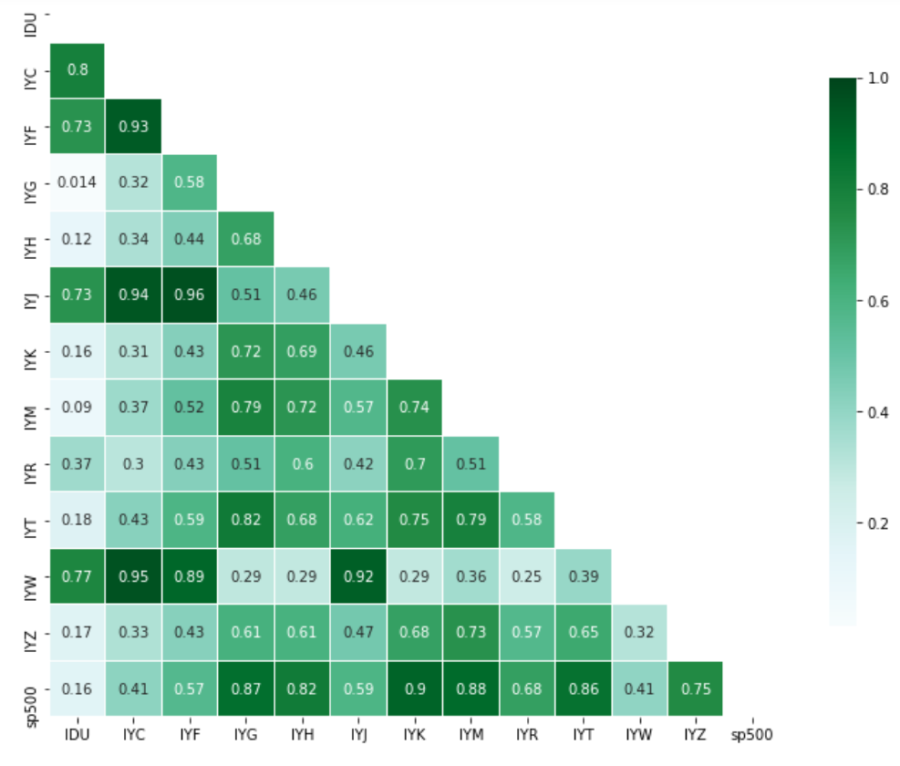

Figure : Correlation coefficients for sector ETFs

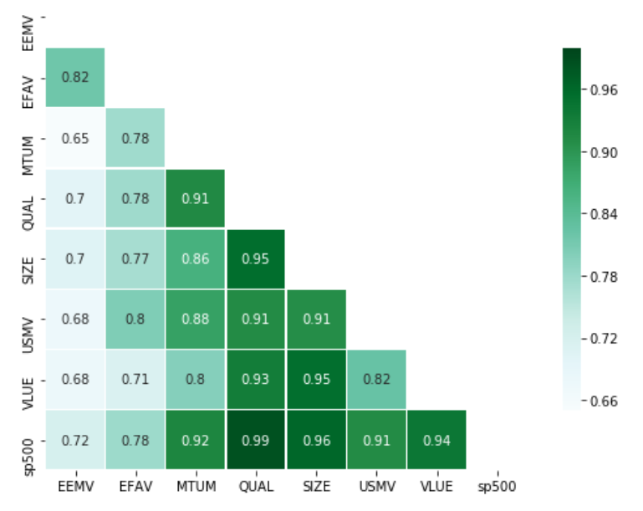

Figure : Correlation coefficients for factor ETFs

## 5.2 Building the efficient frontiers

As mentioned, the study closely followed procedures prescribed by Ehling and Ramos (2006) in directly comparing two diversified portfolios. Specifically, the two sets of ETFs were first optimized, which means that finding the lowest standard deviation point given a certain level of return from each set of ETFs and then connecting those dots together, to construct two efficient frontiers. This step served dual purposes: to anchor as a reference frontier and to pick two explicit points (GMV and tangency) as benchmarks. Next, the measures of efficiency were calculated by solving the optimizing problem (P).

And lastly, the BJS 2002 tests were performed to consider the statistical significances of the results.

Figure 4 showed the two efficient frontiers comprised of two distinct sets: factor ETFs (on the left) and sector ETFs. The tangency portfolios (red dots) and global minimum variance GMV (green dots) were also highlighted and will be treated as benchmarks for later comparison purposes. Intuitively, the curved line formed by the factor ETFs (returns ranged from .007 to 0.014, and volatility was from .03 to .04) was more upper left compared to the right one (returns ranged from 0.006 to .01, and volatility was from .035 to .04), indicating the better trade-off between risks and returns for factor portfolios. Since most investors couldn’t lend or borrow at the risk-free rate, the study ignored investigating the slope of the capital market line which was formed by connecting the tangency portfolio and the risk free rate (the dash, red line in the charts), and considered solely performances of the two efficient frontiers.

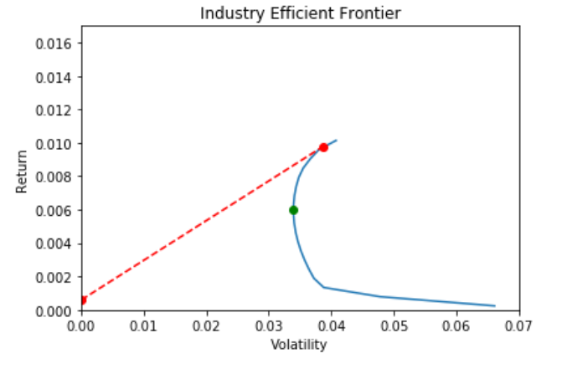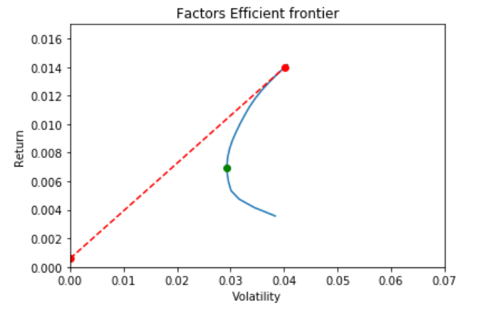

Figure : Efficient frontiers for factor and sector ETFs

By solving the problem (P) first for factor ETFs, the mimicking portfolios, which had exact returns of the benchmarks, were identified as black dots lining in the factor efficient frontier. The benchmarks were selected from either the other frontier: the tangency and global minimum variance portfolios, or the S&P500 index as the market portfolio.

## 5.3 Beating the market

Followed the BJS 2002, to test the performances of the two approaches, the study measured the distance between the market portfolio (represented by the S&P500 index) and its identical return portfolios lining in each efficient frontier. If the market portfolio lies on the right of the efficient frontiers, it means that given the same level of return, the market portfolio is riskier (higher volatility) for investors.

Figure 5 reasonably expressed the greater distance when compared the market portfolio (green dots) with the factor efficient frontier than that of the sector/industry frontier. The latter observation was consistent with Roll (1992): “national stock markets reflect the idiosyncracies of the country's industrial structure”, in other words, industry-allocated portfolio was an efficient diversification technique to approximately replicate performances of the market.

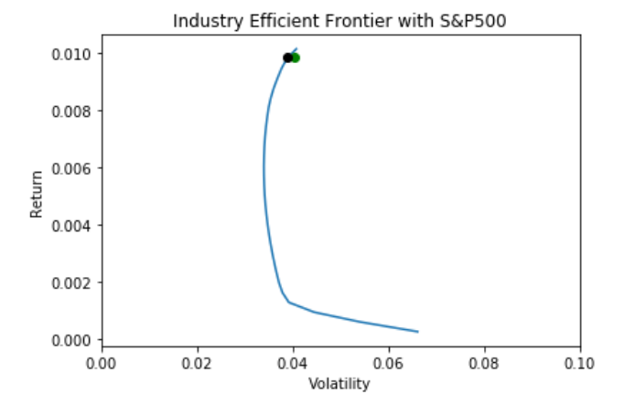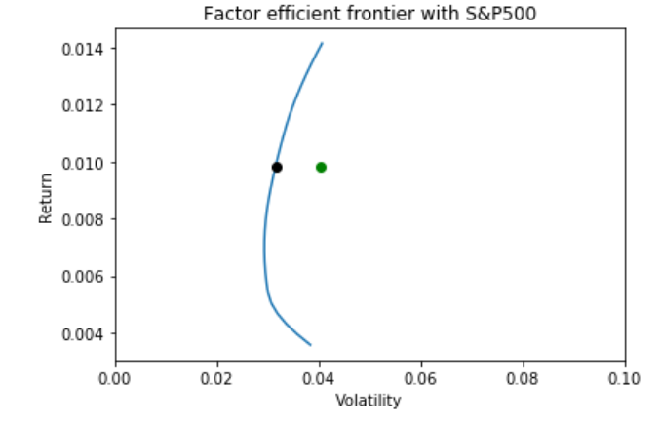

Figure : Beating the market portfolio

The research first considered the full period (2013-2020) and then the pandemic period (2020) to investigate whether the outcomes resulted differently under volatile times. The results are distinctly supportive for factor approach for the former sample, whereas the latter is not statistically significant.

Table 3 showed that factor investing outperformed the market during normal time and the pandemic with high statistical significances, while the superior of sector investing was statistically less obvious. Since factor investing captured risk premiums by simultaneously longing positive exposures and shorting negative exposures, while S&P500 index reflected only the set of 500 largest stocks in the market, the prevailing performance of optimal factor approach implied the fact that investors were indeed rewarded for the extra exposures such as value, size, or momentum.

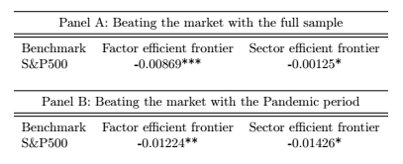Table : The measures of efficiency between market portfolio and efficient frontiers

Notes to table: Panel A reports the distances between the market portfolio with two identical return counterparts lining in the factor and sector efficient frontiers, while Panel B calculated only for the pandemic period. The significant tests were also reported with ***, **, and * are correspond to 1%, 5%, and 10% significant level, respectively from August 2013 to December 2020

## 5.4 Efficient frontier comparison: factor outperformed sector

The rationales behind sector and factor investing are disparate: while the former tries to diversify as much as possible the idiosyncratic risks in order to obtain the same level of market returns (a reasonable return for accepting the market risk), the latter exploits potential risk premiums found by various exposures such as size, value, volatility or momentum, not just the market risk. Diversification benefits, especially through combining various industries, have been proven essential, not just in academic literatures, but also in practice which reflected by the trillions of dollars investing in this kind, and the portion of funds allocated into this passive channel has surged year after year. Hong et al. (2007), running a multivariate regressions of market returns (as dependent variable) on various industry returns for the period from 1942 to 2000, showed that at some extent, the performance of stock market today indeed could be predicted by using a large number of industry returns two months earlier. Moreover, Fama and French (2010), revealed the observation that “whatever one takes to beat the market, for example, value stocks, growth stocks, etc., active investors can only win at the expense of other active investors. In short, active investing in any sector is always a zero-sum game”. All these researches imply the uphill battle for factor investing when put next to a well-established sector investing approach.

However, empirical results from the study supported the factor approach. Specifically, the two benchmark portfolios, which were assembled from sector ETFs as shown in the following charts, were apparently inefficient compared to the mimicking portfolios which lied in the factor efficient frontier: given the same expected returns, the benchmarks were riskier measured by the higher values of volatility. Considering the sector’ tangency portfolio as a benchmark, the volatility was about 0.03869 compared to 0.03146 of the identical-return (0.00978) mimicking portfolio.

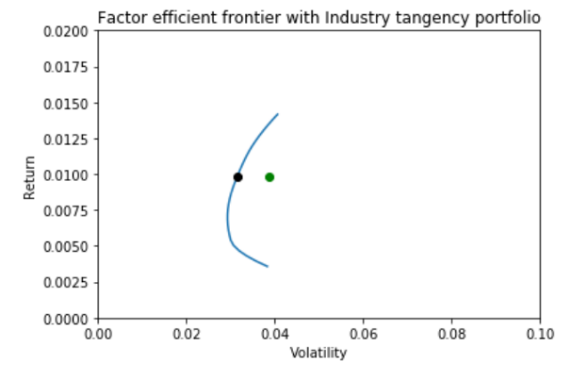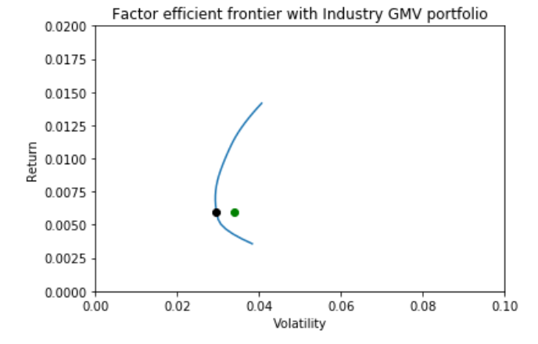

Figure : Factor outperformed sector

The same pattern happened when treating sector’s global minimum variance portfolio as a benchmark, its volatility was 0.03395 which was much higher when compared to 0.02962 of the comparable counterpart portfolio lining in the factor efficient frontier.

To statistically establish the significance of the observation above, the study performed the test of the BJS (2002) with the null hypothesis was defined as:

*H0: “The benchmark portfolios are mean-variance efficient compared to the mimicking portfolios which line in the efficient frontier”*

Put if differently, the null claimed that there was no statistically significant distinction between the interested portfolios. In case of rejecting the null, if the measure of efficiency, , is negative, the benchmark portfolio has a higher volatility compared to the mimicking portfolio comprised from the primitive assets, and hence it is considered as mean-variance inefficient.

Table 4 displayed the measures of efficiency which were calculated by using factor and sector ETFs in turn as benchmarks and examined against the other. In the full period sample, the noticeable conclusion was that factor ETFs dominated sector ETFs, reflected through the negative values of the measures of efficiency when factor ETFs were used as primitive assets, and positive values when treating sector ETFs as primitive assets. All the reported results in this sample were statistically significant to reject the null hypothesis. Principally, a negative value in the second column does not automatically entail a positive value in the third column, and vice versa. The reason is that the efficient frontiers can cross each other, and the tangency and GMV portfolios, which have different expected returns, can locate on different sides of the frontiers.

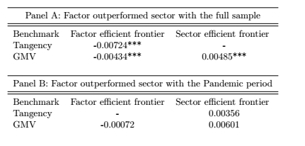Table : The measures of efficiency between factor and sector efficient frontiers

Notes to table: Directly comparing when factor and sector are in turn used as benchmark portfolios with the other reference frontier. Panel A reports results for the full sample, while Panel B reports only for the Pandemic period. The significant tests were also reported with ***, **, and * are correspond to 1%, 5%, and 10% significant level, respectively

In the pandemic period sample, the conclusion was the same (based upon the sign of the measures of efficiency), however, the values were not statistically significant, hence the study couldn’t reject the null hypothesis that the investment approach, whether factor or sector ETFs, exhibits exact volatility for a given expected return.

The fundamental arguments against active investment comprise of two components: highly charged fees and exceedingly concentrated risks. Unlike the transparent approach of passive approach, active portfolio managers, traditionally, had to privately scan through an entire universe of investable stocks to collect proper ones into a pre-defined factor-exposure portfolio. Obviously, this process required unique skills and experiences, not to mention other specific attachments such as computing powers, sophisticated algorithms, and so on. These aspects were generally recognized by investors who wanted to go along with these funds, and this acknowledgement was monetarily echoed through a set of high, various fees. French (2008) concluded that “investor would increase his average annual return by 67 basis points over the 1980 to 2006 period if he switched to a passive market portfolio”. Regarding the undiversified nature of active management, when a factor portfolio was constructed, historical data of those selected stocks, including expected returns, time series of prices or covariance with other stocks, were critical in the process. While the past normally was a good place for an effort of predicting the future, the unanticipated essence of the stock movements regularly brought surprises to these forecasts, and by fixing the portfolio into one specific factor, the possibility of reducing these negative impacts would be extremely meager. However, the validity of these two arguments have been gradually diminished by the creation of exchange traded funds (ETFs).

The obvious observation is that ETFs are less costly than mutual funds. Mutual funds normally charge their investors for almost everything that goes on inside the fund, such as transaction or distribution fees. Furthermore, actively managed funds are sold with a sales load, which is a fee that is charged to investors for the right to investing with those funds. Loads for mutual funds generally range from 1% to 2%. The next significant cost regarding mutual funds is known as the expense ratio, which is the percentage based upon total assets, paid to operate the fund. It includes many categories, but typically only 3 are prominent: the management fee, the distribution fee, and other expenses. And it's not that easy to find out what fees are contained in the "other expenses" category. In addition to paying the portfolio manager's salary, the management fee covers the cost of the investment manager's staff, research, technical equipment, computers, and so on. While fees vary, the average equity mutual fund management fee is about 1.40%. In contrast to mutual funds, ETFs do not charge a load. And ETFs do not have the distribution fees. According to Morningstar, the average ETF expense ratio in 2016 was 0.23%, compared with the average expense ratio of 0.73% for index mutual funds and 1.45% for actively managed mutual funds. Hence, with substantially lower fees, ETFs offer investors an efficient way to adjust their preferences based on various rewarded risks.

Another benefit comes from the fact that ETFs can be traded freely and instantly on exchanges, considerably like stocks. This characteristic allows investors to easily construct their portfolios by combing different factor ETFs, hence brings the possibility of reducing idiosyncratic risks born by each ETF in the portfolios. The fundamental value of sector investing is the promise of diversification, specifically if a set of industries performed negatively, then another set of industries would offset with positive performances, and eventually help the portfolios approach the level of fluctuations of the market. Interestingly, each EFT is assembled commonly by a large number stocks which come from many industries. Figure 7 shows detail percentages of each industry (over ten sectors for each ETF) that are included in the momentum ETF and value ETF, which were provided from BlackRock website.

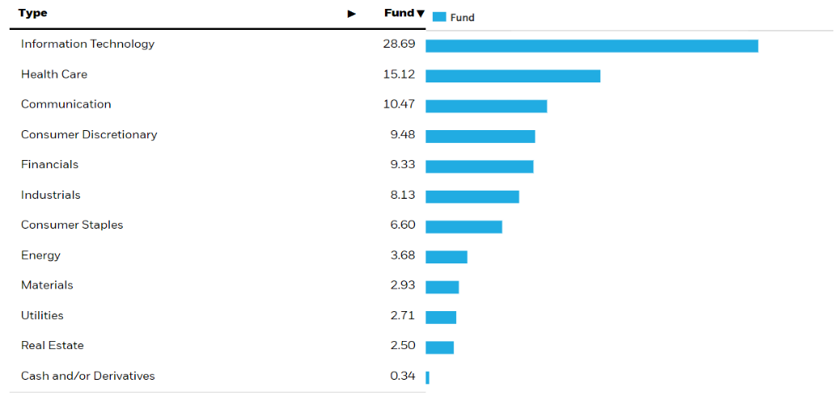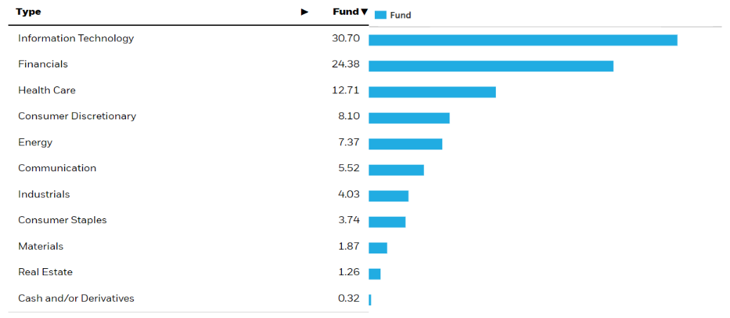

*Source: BlackRock­­­’s website*

Figure : Components of Momentum and Value ETFs

Broadly speaking, each ETF covers almost entire industries in the market with different weights based upon their risk exposures. In addition, with more than a hundred of stocks in each ETF, a portfolio, which comprises from a set of ETFs, is no longer heavily suffered from idiosyncratic risks, but largely provides investors the kind of diversification benefits that sector investing can normally offer.

# 6. Conclusion

The study has compared the performances of factor and sector diversification based upon the statistical test of Basak, Jagannathan, and Sun (2002). Successfully replicating factor exposures from individual stocks may be challenging (Ang et al. (2009)), and not all investors are willing to tediously undertake that work, this study, instead, leveraged the conveniences of accessible exchange traded funds (ETFs) as proxies for both factor and sector investing.

According to the mean-variance efficient test (BJS 2002), factor investing outperformed not only the S&P500 index, but also the sector diversification, both superior performances were proved with statistical significances for the full sample period. Since “performances of multifactor portfolios are more crisis-sensitive than those of passive portfolios” (Briere and Szafarz 2021), this research further investigated whether that observation was true during the highly volatile period: the pandemic 2020. The results were not statistically significant, however, the sign of the tests indicated that indeed factor investing was superior compared to sector investing.

Results from the study provided practical implementations for investors. Specifically, optimally combining different factors into a portfolio not only delivers the risk premiums promised by those strategies, but also potentially outperformed sector diversification and the S&P500 index during normal times and even market downturns, which were mostly considered as the times when those latter approaches were traditionally preferred.

The limited potential, followed by this research, is the sensitivity of newly arrived values. Kim and Boyd (2007) argued that “mean-variance (MV) analysis is often sensitive to model misspecification or uncertainty, meaning that the MV efficient portfolios constructed with an estimate of the model parameters (i.e., the expected return vector and covariance of asset returns) can give very poor performance for another set of parameters that is similar and statistically hard to distinguish from the one used in the analysis”. Put it differently, efficient frontiers were constructed by minimizing volatility of a given return (or maximizing expected return given an identical volatility), and these first two moments (expected return and volatility), which formed on historical data, were statically fixed, any deviation resulted from future values, thus, could drastically change the selected portfolios as benchmarks, and optimal weights in that case were not optimal anymore. Potential research directions for addressing this issue would be that investors should set up a certain upper and lower bound for these weights (no weight should be larger than 0.7 or smaller than 0.1, for instance), to limit the dependency of the portfolio to one specific set of factors, hence it could improve the overall performance of the approach throughout different situations.

# References:

Amenc, Noel, Felix Goltz, Ashish Lodh, and Lionel Martellini, (2014): “Towards Smart Equity Factor Indices: Harvesting Risk Premia Without Taking Unrewarded Risks”, The Journal of Portfolio Management 40: 106–22.

Ang, A., W. Goetzmann, and S. Schaefer, (2009): “Evaluation of active management of the Norwegian GPFG”, Norway: Ministry of Finance.

Andre F. Perold, (2004): “The Capital Asset Pricing Model”, Journal of Economic Perspectives 18: 3–24.

Asness, C.S., T. Moskowitsz, and L. Pedersen, (2013): “Value and momentum everywhere”, Journal of Finance 68: 929–985.

Banz, Rolf W., (1981): “The Relationship Between Return and Market Value of Common Stocks”, Journal of Financial Economics 9: 3–18.

Basak G., R. Jagannathan and G. Sun., (2002): “A Direct Test for the Mean-Variance Efficiency of a Portfolio”, Journal of Economic Dynamics and Control 26: 1195–1215.

Basu Sanjoy, (1983): “The Relationship between Earnings Yield, Market Value and Return for NYSE Common Stocks: Further Evidence”, Journal of Financial Economics 12: 129–156.

Barroso, P., and P. Santa-Clara, (2015): “Momentum has its moments”, Journal of Financial economics 116: 111–120.

Brière, M., B. Drut, V. Mignon, K. Oosterlinck and A. Szafarz, (2013): “Is the Market Portfolio Efficient? A New Test of Mean-Variance Efficiency when all assets are Risky”, Finance 34: 7–41.

Briere, M., Szafarz, A., (2021): “When it rains, it pours: Multifactor asset management in good and bad times”, CEBRIG working paper N21–002.

Carhart, Mark M., (1997): “On Persistence in Mutual Fund Performance”, Journal of Finance 52: 57–82.

Chou, P. H., Ko, K. C., Yang, N. T., (2019): “Asset growth, style investing, and momentum”, Journal of Banking & Finance 98: 108–124.

Cochrane, John H., (2011): “Presidential Address: Discount Rates”, Journal of Finance 66: 1047–1108.

De Moor, L. and P. Sercu, (2011): “Country Versus Sector Factors in Equity Returns: The Roles of Non-Unit Exposures”, Journal of Empirical Finance 18: 64–77.

Ehling P. and S.B. Ramos, (2006): “Geographic versus Industry Diversification: Constraints Matter”, Journal of Empirical Finance 13: 396–416.

Fama, Eugene F., (1965a): “The behavior of stock-market prices”, The Journal of Business 38: 34–105.

Fama, Eugene F., (1965b): “Random Walks in Stock Market Prices”, Financial Analysts Journal 21: 55–59.

Fama, Eugene F., and Kenneth R. French, (1993): “Common Risk Factors in the Returns on Stocks and Bonds”, Journal of Financial Economics 33: 3–56.

Fama, Eugene F., and Kenneth R. French., (1996): “Multifactor Explanations of Asset Pricing Anomalies”, Journal of Finance 51: 55–84.

Fama, Eugene F., and Kenneth R. French, (2010): “Luck versus Skill in the Cross-Section of Mutual Fund Returns”, Journal of Finance 65: 1915–1947.

Fama, Eugene F., and Kenneth R. French, (2015): “A Five- Factor Asset Pricing Model”, Journal of Financial Economics 116: 1–22.

French, Kenneth R., (2008): “The Cost of Active Investing”, Available at SSRN: https://ssrn.com/abstract=1105775 or http://dx.doi.org/10.2139/ssrn.1105775.

Hong H., W. Torous, and R. Valkanov, (2007): “Do Industries Lead Stock Markets?”, Journal of Financial Economics 83: 367–396.

Ibbotson, Roger G., Chen, Zhiwu and Kim, Daniel and Hu, Wendy Yunchun, (2013): “Liquidity as an Investment Style”, Financial Analysts Journal 69: 30–44.

Jegadeesh N., and S. Titman, (1993): “Returns to buying winners and selling losers: Implications for stock market efficiency”, Journal of Finance 48: 65–91.

Jensen, Michael., (1968): “The Performance of Mutual Funds in the Period 1945–1964”, Journal of Finance 23, 389–416.

Jensen, Michael., (1978): “Some Anomalous Evidence Regarding Market Efficiency”, Journal of Financial Economics 6: 95–101.

Jobson, J.D, and B.M Korkie, (1981): “Performance hypothesis testing with the Sharpe and Treynor measures”, Journal of Finance 36: 889–908.

Kim, S.-J., Boyd, S., (2007): “Robust efficient frontier analysis with a separable uncertainty model”, Technical report, Department of Electrical Engineering, Stanford University, 1–41.

Li, Y., (2018): “Investment and profitability versus value and momentum: The price of residual risk”, Journal of Empirical finance 46: 1–10.

Lo, W. Andrew, (2017): “Adaptive Markets: Financial evolution at the speed of thought”, Princeton University Press.

Markowitz, Harry, (1952): “Portfolio Selection”, Journal of Finance 7: 71–91.

Mehra, R., and E.C. Prescott, (1985): “The equity premium: A puzzle”, Journal of Monetary economics 15: 145–161.

Mitchell, M., T. Pulvino, and E. Stafford, (2002): “Limited arbitrage in equity markets”, Journal of Finance 57: 551–584.

Novy-Marx, R., (2013): “The other side of value: The gross profitability premium”, Journal of Financial Economics 108: 1–28.

Rosenberg, Barr, Kenneth Reid, and Ronald Lanstein, (1985): “Persuasive Evidence of Market Inefficiency”, Journal of Portfolio Management 11: 9–17.

Samuelson, Paul A., (1965a): “Proof That Properly Anticipated Prices Fluctuate Randomly”, Industrial Management Review 6: 41–49.

Sharpe, William F., (1964): “Capital Asset Prices— A theory of market equilibrium under conditions of risk”, Journal of Finance 19: 425–442.

Sharpe, William F., (1966): “Mutual Fund Performance”, Journal of Business 39: 119–138.

Sharpe, William F., (1991): “The Arithmetic of Active Management”, Financial Analysts Journal Vol. 47: 7–9.

Thomas Delcey, (2019): “Samuelson vs Fama on the Efficient Market Hypothesis: The Point of View of Expertise”, OEconomia-History/Methodology/Philosophy, NecPlus/Association OEconomia, Varia, 9.

Titman, S., Wei, K., Xie, F., (2004): “Capital investments and stock returns”, Journal of Financial and Quantitative Analysis 39: 677–700.

Roll, R., (1992): “Industrial Structure and the Comparative Behavior of International Stock Market Indices”, Journal of Finance 47: 3–41.

# Appendix A: Descriptive figures

## A1: Sector ETFs

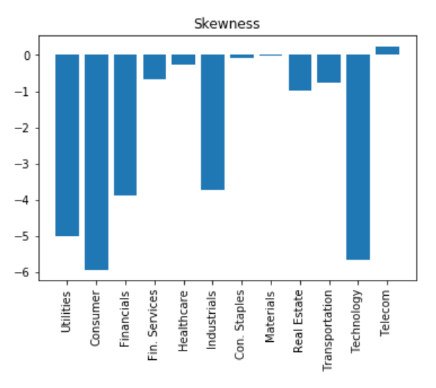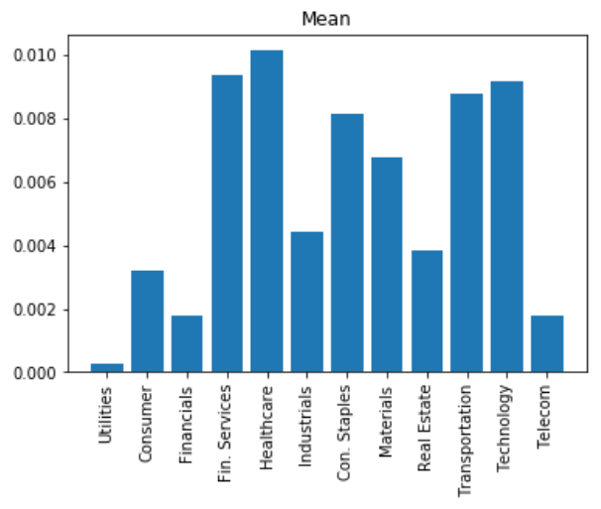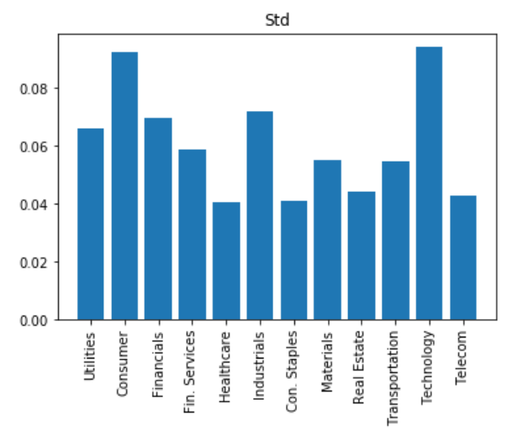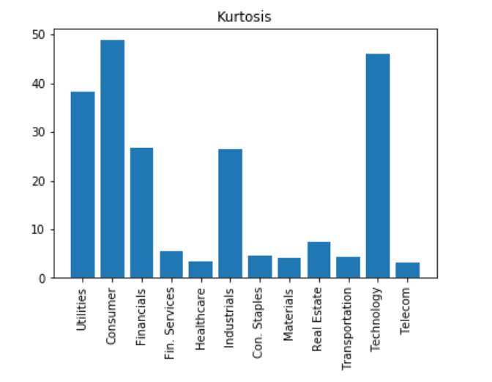

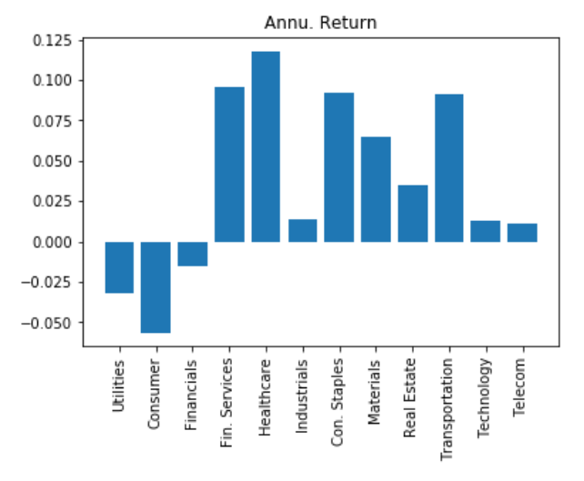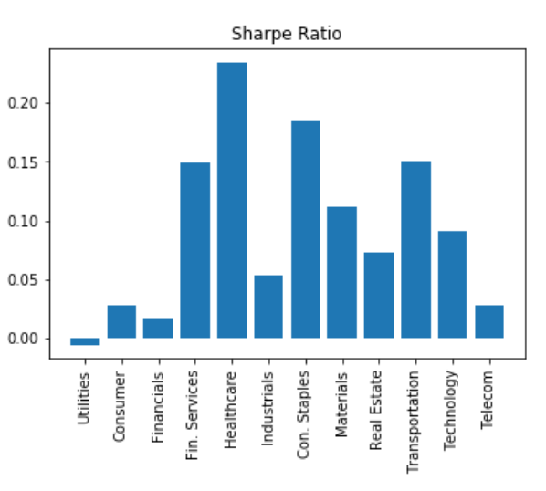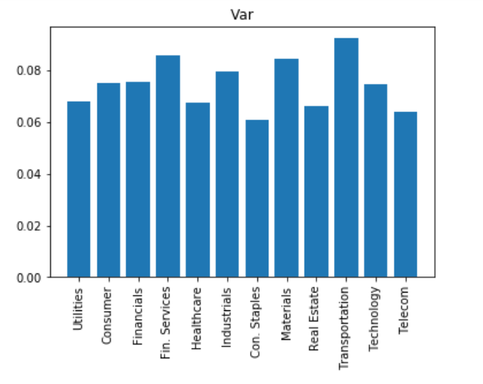

## A2: Factor ETFs

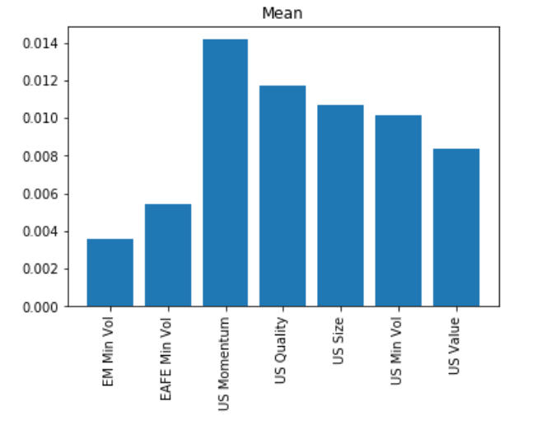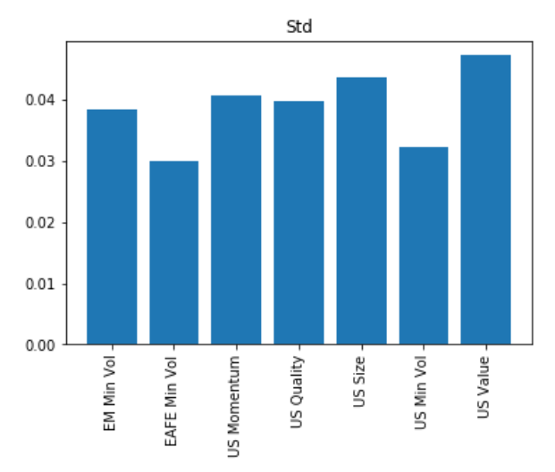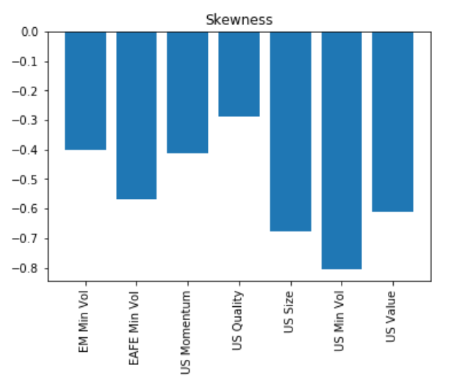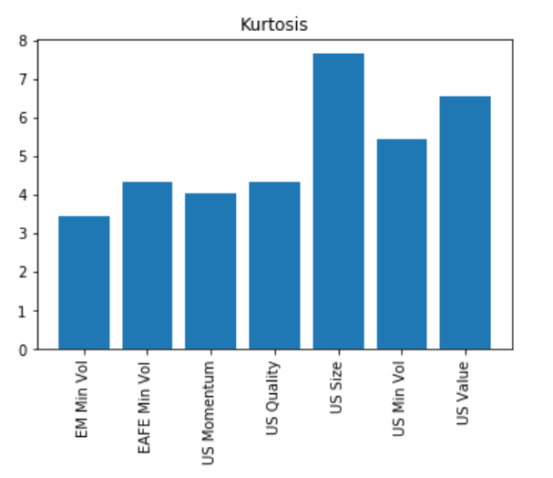

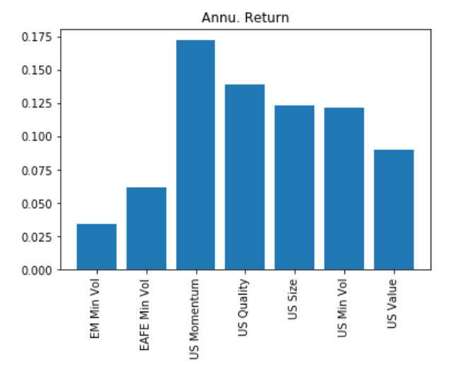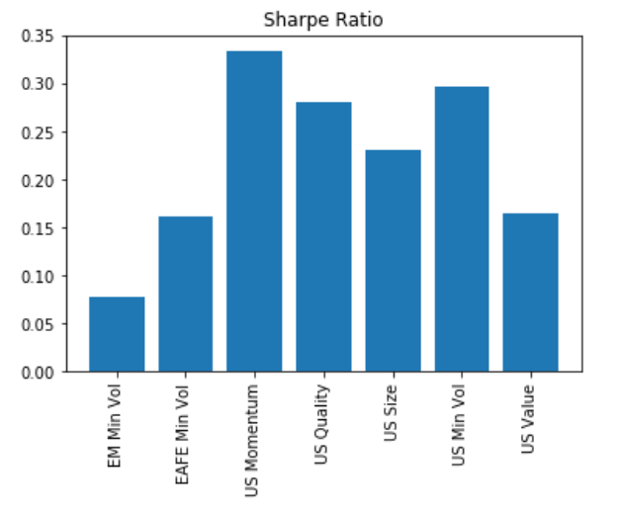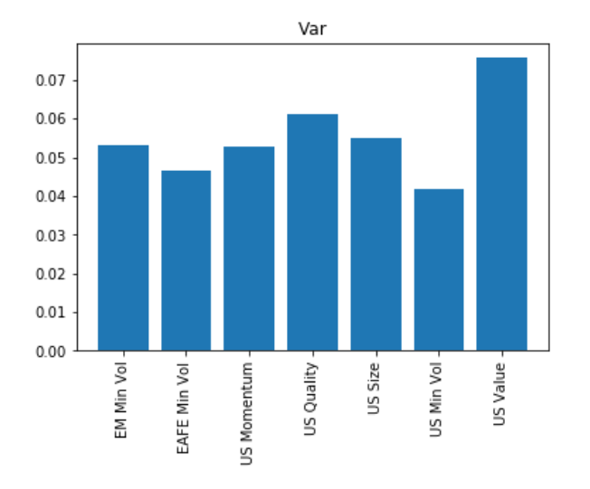

Appendix B: Python codes**[10]**

import pandas as pd

import numpy as np

import scipy.stats as sc

from scipy.optimize import minimize

import matplotlib.pyplot as plt

# reading dataframes

def get_df (file_name, path=path):

df = pd.read_excel(f'{path}{file_name}', parse_dates=True, header=0, index_col=0)

df.index = pd.to_datetime(df.index, format='%Y%m').to_period('M')

df.columns = df.columns.str.strip()

return df

def get_df_excel (file_name, path=path):

df = pd.read_excel(f'{path}{file_name}', parse_dates=True, header=0, index_col=0)

df.index = pd.to_datetime(df.index, format='%Y%m').to_period('M')

df.columns = df.columns.str.strip()

return df

def sharpe_ratio (r, rf):

return (r.mean() - rf)/r.std()

def get_skewness (return_series):

e = (return_series - return_series.mean())**3

skewness = e.mean() / ((return_series.std(ddof=0))**3)

return skewness

def get_kurtosis (return_series):

de_mean = (return_series - return_series.mean())**4

kurtosis = de_mean.mean() / ((return_series.std(ddof=0))**4)

return kurtosis

def drawdown (return_series: pd.Series):

wealth = np.multiply(1000, (1 + return_series).cumprod())

peak = wealth.cummax()

drawdown = (wealth - peak) / peak

result = pd.DataFrame({'Wealth': wealth, 'Peak': peak, 'Drawdown': drawdown})

return result

def var_historic (r, level=5): # confident level at 95%

if isinstance(r, pd.DataFrame):

return r.aggregate(var_historic, level=level)

elif isinstance(r, pd.Series):

return -np.percentile(r, q=level)

else:

raise TypeError('Expected type is Series or DataFrame')

def annualize_ret (r, period_per_year=12):

compounded_growth = (1+r).prod()

n_period = r.shape[0]

ann_ret = compounded_growth**(period_per_year/n_period) - 1

return ann_ret

# Minimizing volatility function

def minimize_vol (target_ret, er, cov):

n = er.shape[0]

init_guess = np.repeat(1/n, n)

bnd = ((0.0, 1.0),)*n

ret_is_target = {

'type': 'eq',

'args': (er,),

'fun': lambda weights, er: target_ret -portfolio_expected_ret(weights, er)}

weights_sum_to_1 = {

'type': 'eq',

'fun': lambda weights: np.sum(weights) – 1}

result = minimize(fun=portfolio_vol, x0=init_guess, args=(cov,), method='SLSQP', options={'disp': False},

constraints=(ret_is_target, weights_sum_to_1),

bounds=bnd)

return result.x

def optimal_w (er, cov, n_points=19):

target_ret = np.linspace(er.min(), er.max(), n_points)

weights = [minimize_vol(target_return, er, cov) for target_return in target_ret]

return weights

def optimal_w_bm (bm_ret, er, cov):

weights = minimize_vol(bm_ret, er, cov)

return weights

# portfolio return and vol

def portfolio_expected_ret (weight, ret):

return weight.T @ ret

def portfolio_vol (weight, covariance):

return (weight.T @ covariance @ weight)**0.5

def annualize_vol (r, period_per_year=12):

return r.std()*(period_per_year**0.5)

def portfolio_max_sharpe (riskfree_rate, er, cov):

n = er.shape[0]

init_guess = np.repeat(1/n, n)

bnd = ((0.0, 1.0),)*n

weights_sum_to_1 = {

'type': 'eq',

'fun': lambda weights: np.sum(weights) – 1}

def neg_sharpe (weights, riskfree_rate, er, cov):

r = portfolio_expected_ret(weights, er)

vol = portfolio_vol(weights, cov)

return -(r - riskfree_rate)/vol

result = minimize(fun=neg_sharpe, x0=init_guess, args=(riskfree_rate, er, cov,),

method='SLSQP', options={'disp': False},

constraints=(weights_sum_to_1),

bounds=bnd)

return result.x

def gmv (cov): # global minimum variance portfolio weights

n = cov.shape[0]

gmv = portfolio_max_sharpe(0, np.repeat(1, n), cov)

return gmv

# plotting the efficient frontier

def plot_ef (er, cov, n_points=19, riskfree_rate=0.1, title='', show_ew=False, show_gmv=False, show_cml=False):

weight = optimal_w(er, cov, n_points)

port_ret = [portfolio_expected_ret(w, er) for w in weight]

port_vol = [portfolio_vol(w, cov) for w in weight]

ef = pd.DataFrame({'Return': port_ret, 'Volatility': port_vol})

ax = ef.plot.line(x='Volatility', y='Return', legend=None)

ax.set_title(f'{title}')

ax.set_ylabel('Return')

if show_ew:

n = er.shape[0]

ew = np.repeat(1/n, n)

r_ew = portfolio_expected_ret(ew, er)

vol_ew = portfolio_vol(ew, cov)

# draw a point of the equally weghted portfolio

ax.plot([vol_ew], [r_ew], color='goldenrod', marker='o')

if show_gmv:

w_gmv = gmv(cov)

r_gmv = portfolio_expected_ret(w_gmv, er)

vol_gmv = portfolio_vol(w_gmv, cov)

ax.plot([vol_gmv], [r_gmv], color='green', marker='o')

if show_cml:

ax.set_xlim(left=0, right=0.07)

ax.set_ylim(bottom=0, top=0.017)

w_best = portfolio_max_sharpe(riskfree_rate, er, cov)

r_best = portfolio_expected_ret(w_best, er)

vol_best = portfolio_vol(w_best, cov)

# draw a Capital Market Line (cml)

x_cml = [0, vol_best]

y_cml = [riskfree_rate, r_best]

ax.plot(x_cml, y_cml, color='red', marker='o', linestyle='dashed')

return ax

# Plotting efficient frontier with benchmark portfolio

def plot_ef_with_bm (er, cov, bm, n_points=19, riskfree_rate=0.1, title='', show_ef_point=False, show_bm=False):

weight = optimal_w(er, cov, n_points)

port_ret = [portfolio_expected_ret(w, er) for w in weight]

port_vol = [portfolio_vol(w, cov) for w in weight]

ef = pd.DataFrame({'Return': port_ret,

'Volatility': port_vol})

ax = ef.plot.line(x='Volatility', y='Return', legend=None)

ax.set_title(f'{title}')

ax.set_ylabel('Return')

if show_bm:

ax.set_xlim(0, 0.1)

#ax.set_ylim(0, 0.02)

r_gmv = bm[0]

vol_gmv = bm[1]

ax.plot([vol_gmv], [r_gmv], color='green', marker='o')

if show_ef_point:

w_ef = optimal_w_bm(bm[0], er, cov)

r_ef = portfolio_expected_ret(w_ef, er)

vol_ef = portfolio_vol(w_ef, cov)

ax.plot([vol_ef], [r_ef], color='black', marker='o')

return ax

# getting the counterpart portfolio in the efficient frontier

def spotting_p (bm, er, cov):

w_ef = optimal_w_bm(bm[0], er, cov)

r_ef = portfolio_expected_ret(w_ef, er)

vol_ef = portfolio_vol(w_ef, cov)

res = pd.DataFrame({'Weight': w_ef,

'Return': r_ef,

'Vol': vol_ef})

return res

def calculating_ef (er, cov, n_points=19, riskfree_rate=0.1, name=''):

weight = optimal_w(er, cov, n_points)

port_ret = [portfolio_expected_ret(w, er) for w in weight]

port_vol = [portfolio_vol(w, cov) for w in weight]

ef = pd.DataFrame({'Return': port_ret,

'Volatility': port_vol,

'Approach': name})

return ef

def port_gmv (er, cov):

w_gmv = gmv(cov)

r_gmv = portfolio_expected_ret(w_gmv, er)

vol_gmv = portfolio_vol(w_gmv, cov)

return r_gmv, vol_gmv

def port_tangency (riskfree_rate, er, cov):

w_best = portfolio_max_sharpe(riskfree_rate, er, cov)

r_best = portfolio_expected_ret(w_best, er)

vol_best = portfolio_vol(w_best, cov)

return r_best, vol_best

# get descriptive statistics

def get_descriptive (df, l, func_name):

des = df.describe()

for i in range(0, len(l)):

row_name = l[i]

func = func_name[i]

if row_name == "Sharpe ratio":

row_val = func(df, rf).values

else:

row_val = func(df).values

des.loc[-1] = row_val

des.rename(index={-1: row_name}, inplace=True)

return des

# create correlation matrix

def corr_map (df, fig=(10, 8), tittle='Pearson Correlation Matrix'):

mask = np.zeros_like(df[df.columns].corr(), dtype=np.bool)

mask[np.triu_indices_from(mask)] = True

f, ax = plt.subplots(figsize=fig)

plt.title(tittle,fontsize=23)

sns.heatmap(df[df.columns].corr(),linewidths=0.25, vmax=1.0, square=True, cmap="BuGn",

linecolor='w', annot=True, mask=mask, cbar_kws={"shrink": .75})

plt.savefig(f'{path}{tittle}')

return f.tight_layout()

# mapping column’s names with its tickers

def mapping_column_name (df, col_name):

res = {}

for i in range(0, len(col_name)):

o = df.columns[i]

r = col_name[i]

res[o] = r

return res

# drawing descriptive figures

def drawing_des (df, cri, int_func):

for i in range(0, len(int_func)):

plt.figure()

cri = int_func[i]

plt.bar(df.columns,df.loc[cri])

plt.title(f'{cri}')

plt.xticks(rotation='vertical')

# merging dataframes

def merging_df (df1, df2):

res = pd.merge(df1, df2, how='left', left_index=True, right_index=True)

return res

# Calculating the test statistics according to the BJS 2002

def calculating_bjs (portfolio_p, primitive_asset, benchmark):

w_p = portfolio_p['Weight'].values

r_p = primitive_asset @ w_p

std_p = r_p.std()

# calculating lambda

lamda = std_p - benchmark[1]

# getting the BJS 2002 statistical results

l = []

for t in range(1, primitive_asset.shape[0]):

f = primitive_asset.iloc[:t, :].values

r = f @ w_p.T

s = r.std()

l.append(s - benchmark[1])

l = np.array(l)

l_std = l.std()

# calculating z score

return z = lamda * np.sqrt(primitive_asset.shape[0]) / l_std

1. . The term was introduced by Cochrane (2011) in describing a great number of available factors regarding asset pricing models.
2. . A variable X follows a Martingale model if and only if:
3. . A random walk model assumes that the steps, in which the variable takes each time away from their current value, are to be independently and identically distributed.
4. . Earnings per share over Price per share. The nominator is first calculated as a company’s total profit over the outstanding shares of common stocks while the denominator is retrieved from the market price
5. . Book value over Market value: the nominator is derived from financial statement in common equity item, while the denominator is the multiplication of market price per share with its outstanding shares
6. . It is generally defined as a ratio of trading volume over outstanding shares
7. . “The anatomy of smart beta”, https://content.ftserussell.com/sites/default/files/research/the-anatomy-of-smart-beta-final-1.pdf
8. . I thank NEOMA Business School for granting me access to this database
9. Kindly refer to Appendix A for more detail descriptive figures regarding to both sector and factor ETFs over the review period
10. . Inspired by lessons from the course: “Introduction to Portfolio Construction and Analysis with Python”, taught by Vijay Vaidyanathan, Phd